Mark Joiner

Assignment 6.2

2/7/2025

Last couple of lines I see:

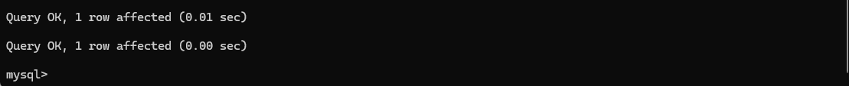

Show Tables command:

Mysql_test.py running:

